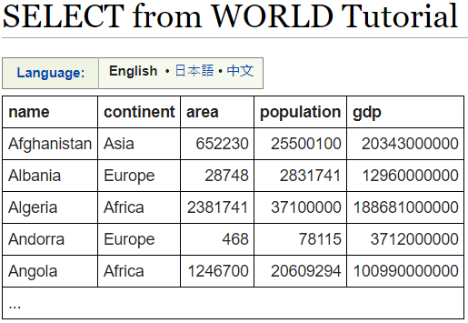

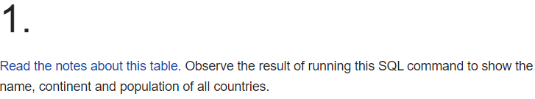

**SELECT name, continent, population FROM world**

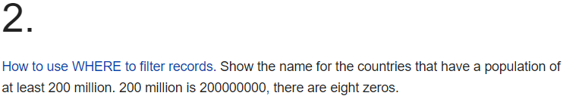

**SELECT name FROM world WHERE population > 200000000**

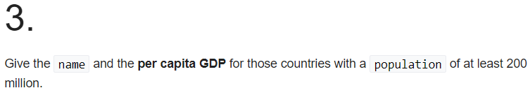

**SELECT name, gdp/population FROM world WHERE population = 200000000 or population > 200000000**

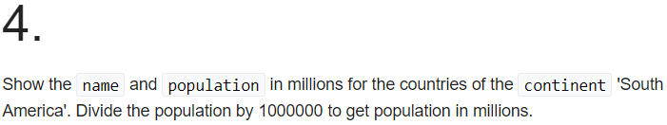

**SELECT name,population/1000000 FROM world WHERE continent = 'South America'**

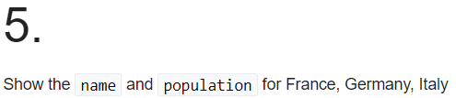

**SELECT name,population FROM world WHERE name IN ('France','Germany','Italy')**

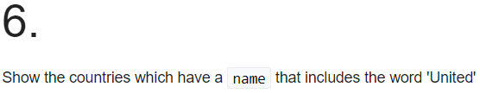

**SELECT name FROM world WHERE name LIKE '%United%'**

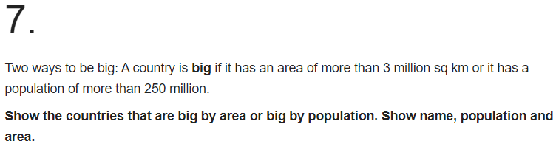

**SELECT name,population,area FROM world WHERE area > 3000000 OR population > 250000000**

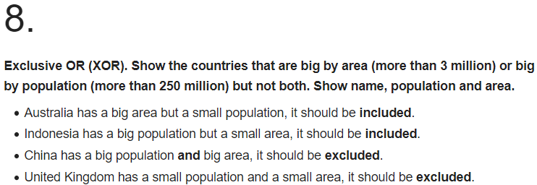

**SELECT name,population,area FROM world WHERE area > 3000000 XOR population > 250000000**

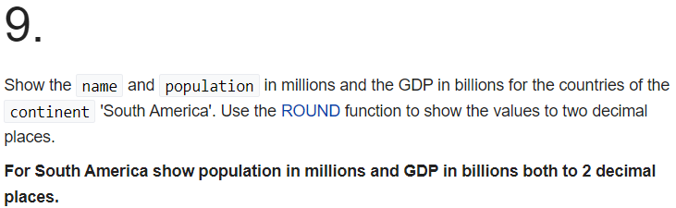

**SELECT name,ROUND(population/1000000,2),ROUND(gdp/1000000000,2) FROM world WHERE continent = 'South America'**

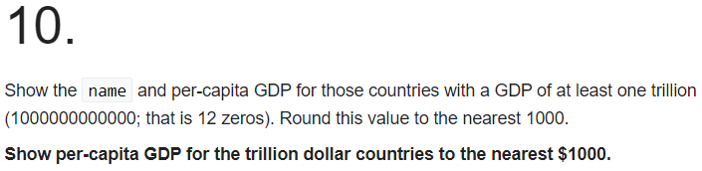

**SELECT name,ROUND(gdp/population,-3) FROM world WHERE gdp = 1000000000000 or gdp > 1000000000000**

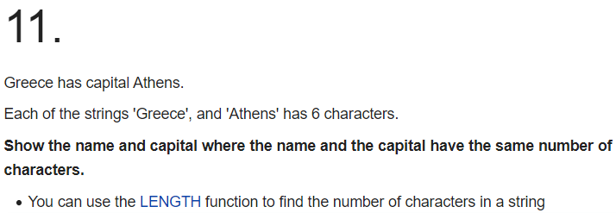

**SELECT name,capital FROM world WHERE LENGTH(name) = LENGTH(capital)**

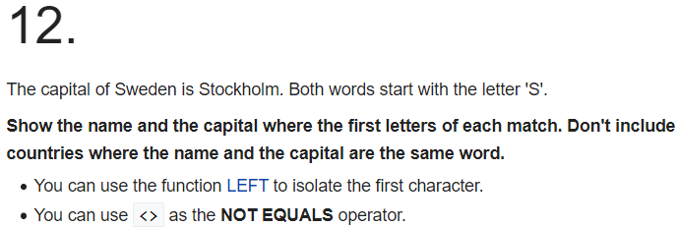

**SELECT name,capital FROM world WHERE LEFT(name,1) = LEFT(capital,1) and name <> capital**

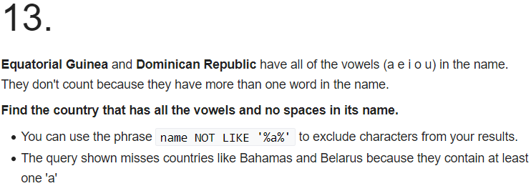

**SELECT name FROM world WHERE name LIKE '%a%'**

**AND name LIKE '%e%'**

**AND name LIKE '%i%'**

**AND name LIKE '%o%'**

**AND name LIKE '%u%'**

**AND name NOT LIKE '% %'**